Setting Up Kafka on Windows

# **Download & Extract Zookeeper and Kafka (binary) as shown below**

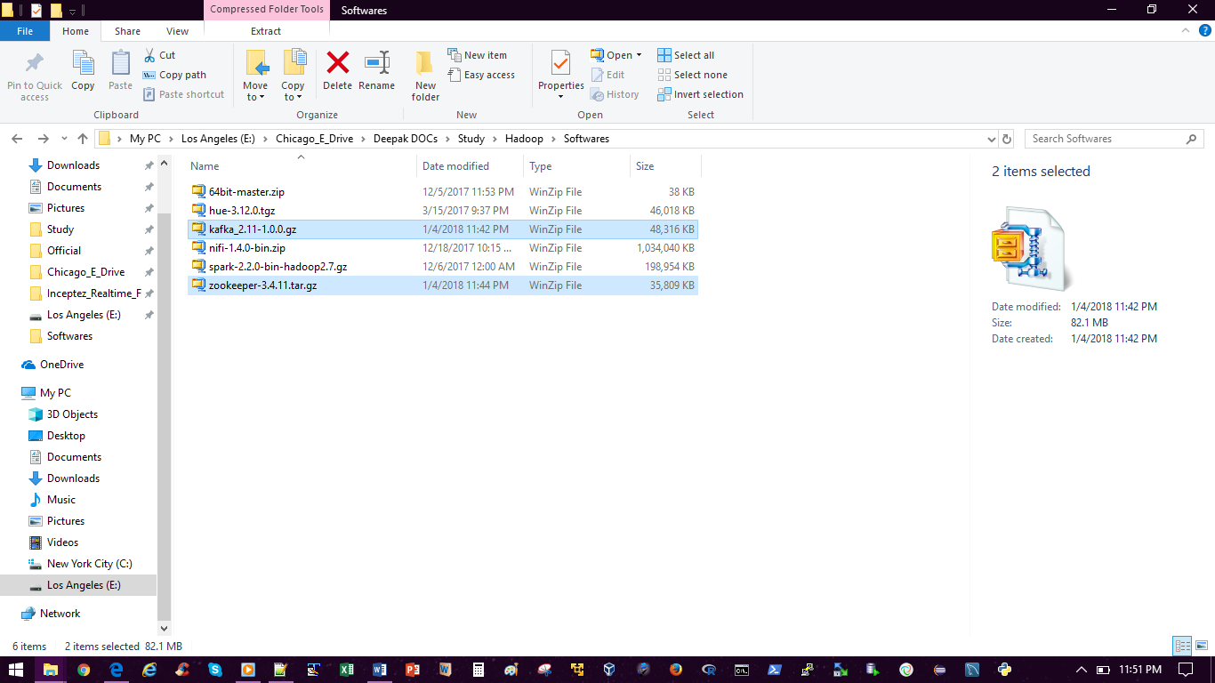

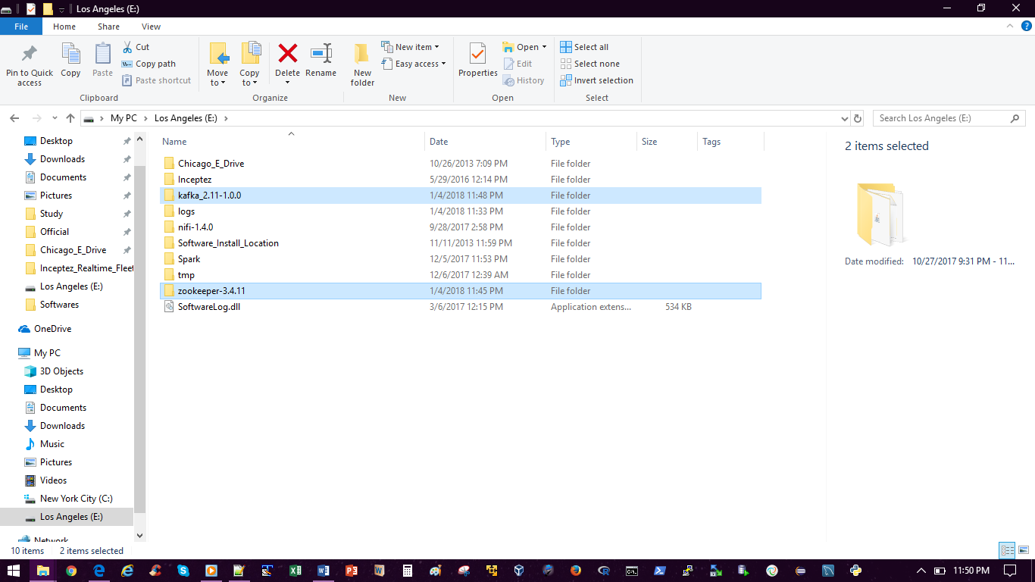

# **Rename and Edit Zookeeper config file**

1. Go to E:\zookeeper-3.4.11\conf\ and rename the file “zoo_sample.cfg” “zoo.cfg”.
2. Edit “zoo.cfg” file and change the line “dataDir=/tmp/zookeeper” to “dataDir=E:\zookeeper-3.4.11\data”

# **Add Environment Variables**

ZOOKEEPER_HOME = E:\zookeeper-3.4.11

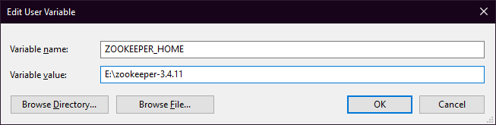

Add E:\zookeeper-3.4.11\bin to PATH

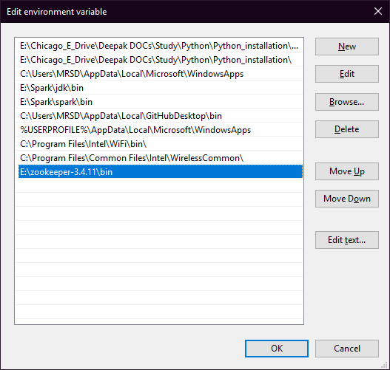

# **Start Zookeeper**

Open a new command window and type the below command.

**PS C:\Users\MRSD> zkserver**

C:\Users\MRSD>call "E:\Spark\jdk"\bin\java "-Dzookeeper.log.dir=E:\zookeeper-3.4.11\bin\.." "-Dzookeeper.root.logger=INFO,CONSOLE" -cp "E:\zookeeper-3.4.11\bin\..\build\classes;E:\zookeeper-3.4.11\bin\..\build\lib\*;E:\zookeeper-3.4.11\bin\..\*;E:\zookeeper-3.4.11\bin\..\lib\*;E:\zookeeper-3.4.11\bin\..\conf" org.apache.zookeeper.server.quorum.QuorumPeerMain "E:\zookeeper-3.4.11\bin\..\conf\zoo.cfg"

2018-01-04 23:59:50,953 [myid:] - INFO [main:QuorumPeerConfig@136] - Reading configuration from: E:\zookeeper-3.4.11\bin\..\conf\zoo.cfg

2018-01-04 23:59:50,973 [myid:] - INFO [main:DatadirCleanupManager@78] - autopurge.snapRetainCount set to 3

2018-01-04 23:59:50,973 [myid:] - INFO [main:DatadirCleanupManager@79] - autopurge.purgeInterval set to 0

2018-01-04 23:59:50,974 [myid:] - INFO [main:DatadirCleanupManager@101] - Purge task is not scheduled.

2018-01-04 23:59:50,979 [myid:] - WARN [main:QuorumPeerMain@116] - Either no config or no quorum defined in config, running in standalone mode

2018-01-04 23:59:51,180 [myid:] - INFO [main:QuorumPeerConfig@136] - Reading configuration from: E:\zookeeper-3.4.11\bin\..\conf\zoo.cfg

2018-01-04 23:59:51,182 [myid:] - INFO [main:ZooKeeperServerMain@98] - Starting server

2018-01-04 23:59:55,811 [myid:] - INFO [main:Environment@100] - Server environment:zookeeper.version=3.4.11-37e277162d567b55a07d1755f0b31c32e93c01a0, built on 11/01/2017 18:06 GMT

2018-01-04 23:59:55,812 [myid:] - INFO [main:Environment@100] - Server environment:host.name=Deepak

2018-01-04 23:59:55,813 [myid:] - INFO [main:Environment@100] - Server environment:java.version=1.8.0_152

2018-01-04 23:59:55,813 [myid:] - INFO [main:Environment@100] - Server environment:java.vendor=Oracle Corporation

2018-01-04 23:59:55,814 [myid:] - INFO [main:Environment@100] - Server environment:java.home=E:\Spark\jdk\jre

2018-01-04 23:59:55,814 [myid:] - INFO [main:Environment@100] - Server environment:java.class.path=E:\zookeeper-3.4.11\bin\..\build\classes;E:\zookeeper-3.4.11\bin\..\build\lib\*;E:\zookeeper-3.4.11\bin\..\zookeeper-3.4.11.jar;E:\zookeeper-3.4.11\bin\..\lib\audience-annotations-0.5.0.jar;E:\zookeeper-3.4.11\bin\..\lib\jline-0.9.94.jar;E:\zookeeper-3.4.11\bin\..\lib\log4j-1.2.16.jar;E:\zookeeper-3.4.11\bin\..\lib\netty-3.10.5.Final.jar;E:\zookeeper-3.4.11\bin\..\lib\slf4j-api-1.6.1.jar;E:\zookeeper-3.4.11\bin\..\lib\slf4j-log4j12-1.6.1.jar;E:\zookeeper-3.4.11\bin\..\conf

2018-01-04 23:59:55,815 [myid:] - INFO [main:Environment@100] - Server environment:java.library.path=E:\Spark\jdk\bin;C:\WINDOWS\Sun\Java\bin;C:\WINDOWS\system32;C:\WINDOWS;C:\ProgramData\Oracle\Java\javapath;C:\Program Files (x86)\PC Connectivity Solution\;E:\Chicago_E_Drive\Deepak DOCs\Study\Rexx_Clist_Panel_Skeleton\Regina_Latest\Regina;C:\Program Files (x86)\Skype\Phone\;C:\WINDOWS\system32;C:\WINDOWS;C:\WINDOWS\System32\Wbem;C:\WINDOWS\System32\WindowsPowerShell\v1.0\;C:\Program Files (x86)\ATI Technologies\ATI.ACE\Core-Static;E:\Chicago_E_Drive\Deepak DOCs\Study\PCF\CloudFoundry;C:\Program Files\Intel\WiFi\bin\;C:\Program Files\Common Files\Intel\WirelessCommon\;E:\Chicago_E_Drive\Deepak DOCs\Study\Python\Python_installation\Scripts\;E:\Chicago_E_Drive\Deepak DOCs\Study\Python\Python_installation\;C:\Users\MRSD\AppData\Local\Microsoft\WindowsApps;E:\Spark\jdk\bin;E:\Spark\spark\bin;C:\Users\MRSD\AppData\Local\GitHubDesktop\bin;C:\Users\MRSD\AppData\Local\Microsoft\WindowsApps;C:\Program Files\Intel\WiFi\bin\;C:\Program Files\Common Files\Intel\WirelessCommon\;E:\zookeeper-3.4.11\bin;;.

2018-01-04 23:59:55,816 [myid:] - INFO [main:Environment@100] - Server environment:java.io.tmpdir=C:\Users\MRSD\AppData\Local\Temp\

2018-01-04 23:59:55,816 [myid:] - INFO [main:Environment@100] - Server environment:java.compiler=<NA>

2018-01-04 23:59:55,821 [myid:] - INFO [main:Environment@100] - Server environment:os.name=Windows 10

2018-01-04 23:59:55,822 [myid:] - INFO [main:Environment@100] - Server environment:os.arch=amd64

2018-01-04 23:59:55,822 [myid:] - INFO [main:Environment@100] - Server environment:os.version=10.0

2018-01-04 23:59:55,823 [myid:] - INFO [main:Environment@100] - Server environment:user.name=MRSD

2018-01-04 23:59:55,823 [myid:] - INFO [main:Environment@100] - Server environment:user.home=C:\Users\MRSD

2018-01-04 23:59:55,824 [myid:] - INFO [main:Environment@100] - Server environment:user.dir=C:\Users\MRSD

2018-01-04 23:59:55,854 [myid:] - INFO [main:ZooKeeperServer@825] - tickTime set to 2000

2018-01-04 23:59:55,855 [myid:] - INFO [main:ZooKeeperServer@834] - minSessionTimeout set to -1

2018-01-04 23:59:55,855 [myid:] - INFO [main:ZooKeeperServer@843] - maxSessionTimeout set to -1

2018-01-04 23:59:56,551 [myid:] - INFO [main:ServerCnxnFactory@117] - Using org.apache.zookeeper.server.NIOServerCnxnFactory as server connection factory

**2018-01-04 23:59:56,557 [myid:] - INFO [main:NIOServerCnxnFactory@89] - binding to port 0.0.0.0/0.0.0.0:2181**

# **Edit Kafka Config files**

Edit the file “E:\kafka_2.11-1.0.0\config\server.properties” and change the line “log.dirs=/tmp/kafka-logs” to “log.dirs=E:\kafka_2.11-1.0.0\kafka-logs”.

# **Start Kafka Server**

Open a new command window, go to the Kafka folder and type the below command.

**PS C:\Users\MRSD> cd E:\kafka_2.11-1.0.0**

**PS E:\kafka_2.11-1.0.0> .\bin\windows\kafka-server-start.bat .\config\server.properties**

[2018-01-05 00:09:33,262] INFO KafkaConfig values:

advertised.host.name = null

advertised.listeners = null

advertised.port = null

alter.config.policy.class.name = null

authorizer.class.name =

auto.create.topics.enable = true

auto.leader.rebalance.enable = true

background.threads = 10

broker.id = 0

broker.id.generation.enable = true

broker.rack = null

compression.type = producer

connections.max.idle.ms = 600000

controlled.shutdown.enable = true

controlled.shutdown.max.retries = 3

controlled.shutdown.retry.backoff.ms = 5000

controller.socket.timeout.ms = 30000

create.topic.policy.class.name = null

default.replication.factor = 1

delete.records.purgatory.purge.interval.requests = 1

delete.topic.enable = true

fetch.purgatory.purge.interval.requests = 1000

group.initial.rebalance.delay.ms = 0

group.max.session.timeout.ms = 300000

group.min.session.timeout.ms = 6000

host.name =

inter.broker.listener.name = null

inter.broker.protocol.version = 1.0-IV0

leader.imbalance.check.interval.seconds = 300

leader.imbalance.per.broker.percentage = 10

listener.security.protocol.map = PLAINTEXT:PLAINTEXT,SSL:SSL,SASL_PLAINTEXT:SASL_PLAINTEXT,SASL_SSL:SASL_SSL

listeners = null

log.cleaner.backoff.ms = 15000

log.cleaner.dedupe.buffer.size = 134217728

log.cleaner.delete.retention.ms = 86400000

log.cleaner.enable = true

log.cleaner.io.buffer.load.factor = 0.9

log.cleaner.io.buffer.size = 524288

log.cleaner.io.max.bytes.per.second = 1.7976931348623157E308

log.cleaner.min.cleanable.ratio = 0.5

log.cleaner.min.compaction.lag.ms = 0

log.cleaner.threads = 1

log.cleanup.policy = [delete]

log.dir = /tmp/kafka-logs

log.dirs = E:kafka_2.11-1.0.0kafka-logs

log.flush.interval.messages = 9223372036854775807

log.flush.interval.ms = null

log.flush.offset.checkpoint.interval.ms = 60000

log.flush.scheduler.interval.ms = 9223372036854775807

log.flush.start.offset.checkpoint.interval.ms = 60000

log.index.interval.bytes = 4096

log.index.size.max.bytes = 10485760

log.message.format.version = 1.0-IV0

log.message.timestamp.difference.max.ms = 9223372036854775807

log.message.timestamp.type = CreateTime

log.preallocate = false

log.retention.bytes = -1

log.retention.check.interval.ms = 300000

log.retention.hours = 168

log.retention.minutes = null

log.retention.ms = null

log.roll.hours = 168

log.roll.jitter.hours = 0

log.roll.jitter.ms = null

log.roll.ms = null

log.segment.bytes = 1073741824

log.segment.delete.delay.ms = 60000

max.connections.per.ip = 2147483647

max.connections.per.ip.overrides =

message.max.bytes = 1000012

metric.reporters = []

metrics.num.samples = 2

metrics.recording.level = INFO

metrics.sample.window.ms = 30000

min.insync.replicas = 1

num.io.threads = 8

num.network.threads = 3

num.partitions = 1

num.recovery.threads.per.data.dir = 1

num.replica.fetchers = 1

offset.metadata.max.bytes = 4096

offsets.commit.required.acks = -1

offsets.commit.timeout.ms = 5000

offsets.load.buffer.size = 5242880

offsets.retention.check.interval.ms = 600000

offsets.retention.minutes = 1440

offsets.topic.compression.codec = 0

offsets.topic.num.partitions = 50

offsets.topic.replication.factor = 1

offsets.topic.segment.bytes = 104857600

port = 9092

principal.builder.class = null

producer.purgatory.purge.interval.requests = 1000

queued.max.request.bytes = -1

queued.max.requests = 500

quota.consumer.default = 9223372036854775807

quota.producer.default = 9223372036854775807

quota.window.num = 11

quota.window.size.seconds = 1

replica.fetch.backoff.ms = 1000

replica.fetch.max.bytes = 1048576

replica.fetch.min.bytes = 1

replica.fetch.response.max.bytes = 10485760

replica.fetch.wait.max.ms = 500

replica.high.watermark.checkpoint.interval.ms = 5000

replica.lag.time.max.ms = 10000

replica.socket.receive.buffer.bytes = 65536

replica.socket.timeout.ms = 30000

replication.quota.window.num = 11

replication.quota.window.size.seconds = 1

request.timeout.ms = 30000

reserved.broker.max.id = 1000

sasl.enabled.mechanisms = [GSSAPI]

sasl.kerberos.kinit.cmd = /usr/bin/kinit

sasl.kerberos.min.time.before.relogin = 60000

sasl.kerberos.principal.to.local.rules = [DEFAULT]

sasl.kerberos.service.name = null

sasl.kerberos.ticket.renew.jitter = 0.05

sasl.kerberos.ticket.renew.window.factor = 0.8

sasl.mechanism.inter.broker.protocol = GSSAPI

security.inter.broker.protocol = PLAINTEXT

socket.receive.buffer.bytes = 102400

socket.request.max.bytes = 104857600

socket.send.buffer.bytes = 102400

ssl.cipher.suites = null

ssl.client.auth = none

ssl.enabled.protocols = [TLSv1.2, TLSv1.1, TLSv1]

ssl.endpoint.identification.algorithm = null

ssl.key.password = null

ssl.keymanager.algorithm = SunX509

ssl.keystore.location = null

ssl.keystore.password = null

ssl.keystore.type = JKS

ssl.protocol = TLS

ssl.provider = null

ssl.secure.random.implementation = null

ssl.trustmanager.algorithm = PKIX

ssl.truststore.location = null

ssl.truststore.password = null

ssl.truststore.type = JKS

transaction.abort.timed.out.transaction.cleanup.interval.ms = 60000

transaction.max.timeout.ms = 900000

transaction.remove.expired.transaction.cleanup.interval.ms = 3600000

transaction.state.log.load.buffer.size = 5242880

transaction.state.log.min.isr = 1

transaction.state.log.num.partitions = 50

transaction.state.log.replication.factor = 1

transaction.state.log.segment.bytes = 104857600

transactional.id.expiration.ms = 604800000

unclean.leader.election.enable = false

zookeeper.connect = localhost:2181

zookeeper.connection.timeout.ms = 6000

zookeeper.session.timeout.ms = 6000

zookeeper.set.acl = false

zookeeper.sync.time.ms = 2000

(kafka.server.KafkaConfig)

[2018-01-05 00:09:33,405] INFO starting (kafka.server.KafkaServer)

[2018-01-05 00:09:33,426] INFO Connecting to zookeeper on localhost:2181 (kafka.server.KafkaServer)

[2018-01-05 00:09:33,465] INFO Starting ZkClient event thread. (org.I0Itec.zkclient.ZkEventThread)

[2018-01-05 00:09:38,065] INFO Client environment:zookeeper.version=3.4.10-39d3a4f269333c922ed3db283be479f9deacaa0f, built on 03/23/2017 10:13 GMT (org.apache.zookeeper.ZooKeeper)

[2018-01-05 00:09:38,066] INFO Client environment:host.name=Deepak (org.apache.zookeeper.ZooKeeper)

[2018-01-05 00:09:38,066] INFO Client environment:java.version=1.8.0_152 (org.apache.zookeeper.ZooKeeper)

[2018-01-05 00:09:38,067] INFO Client environment:java.vendor=Oracle Corporation (org.apache.zookeeper.ZooKeeper)

[2018-01-05 00:09:38,069] INFO Client environment:java.home=E:\Spark\jdk\jre (org.apache.zookeeper.ZooKeeper)

[2018-01-05 00:09:38,070] INFO Client environment:java.class.path=E:\kafka_2.11-1.0.0\libs\aopalliance-repackaged-2.5.0-b32.jar;E:\kafka_2.11-1.0.0\libs\argparse4j-0.7.0.jar;E:\kafka_2.11-1.0.0\libs\commons-lang3-3.5.jar;E:\kafka_2.11-1.0.0\libs\connect-api-1.0.0.jar;E:\kafka_2.11-1.0.0\libs\connect-file-1.0.0.jar;E:\kafka_2.11-1.0.0\libs\connect-json-1.0.0.jar;E:\kafka_2.11-1.0.0\libs\connect-runtime-1.0.0.jar;E:\kafka_2.11-1.0.0\libs\connect-transforms-1.0.0.jar;E:\kafka_2.11-1.0.0\libs\guava-20.0.jar;E:\kafka_2.11-1.0.0\libs\hk2-api-2.5.0-b32.jar;E:\kafka_2.11-1.0.0\libs\hk2-locator-2.5.0-b32.jar;E:\kafka_2.11-1.0.0\libs\hk2-utils-2.5.0-b32.jar;E:\kafka_2.11-1.0.0\libs\jackson-annotations-2.9.1.jar;E:\kafka_2.11-1.0.0\libs\jackson-core-2.9.1.jar;E:\kafka_2.11-1.0.0\libs\jackson-databind-2.9.1.jar;E:\kafka_2.11-1.0.0\libs\jackson-jaxrs-base-2.9.1.jar;E:\kafka_2.11-1.0.0\libs\jackson-jaxrs-json-provider-2.9.1.jar;E:\kafka_2.11-1.0.0\libs\jackson-module-jaxb-annotations-2.9.1.jar;E:\kafka_2.11-1.0.0\libs\javassist-3.20.0-GA.jar;E:\kafka_2.11-1.0.0\libs\javassist-3.21.0-GA.jar;E:\kafka_2.11-1.0.0\libs\javax.annotation-api-1.2.jar;E:\kafka_2.11-1.0.0\libs\javax.inject-1.jar;E:\kafka_2.11-1.0.0\libs\javax.inject-2.5.0-b32.jar;E:\kafka_2.11-1.0.0\libs\javax.servlet-api-3.1.0.jar;E:\kafka_2.11-1.0.0\libs\javax.ws.rs-api-2.0.1.jar;E:\kafka_2.11-1.0.0\libs\jersey-client-2.25.1.jar;E:\kafka_2.11-1.0.0\libs\jersey-common-2.25.1.jar;E:\kafka_2.11-1.0.0\libs\jersey-container-servlet-2.25.1.jar;E:\kafka_2.11-1.0.0\libs\jersey-container-servlet-core-2.25.1.jar;E:\kafka_2.11-1.0.0\libs\jersey-guava-2.25.1.jar;E:\kafka_2.11-1.0.0\libs\jersey-media-jaxb-2.25.1.jar;E:\kafka_2.11-1.0.0\libs\jersey-server-2.25.1.jar;E:\kafka_2.11-1.0.0\libs\jetty-continuation-9.2.22.v20170606.jar;E:\kafka_2.11-1.0.0\libs\jetty-http-9.2.22.v20170606.jar;E:\kafka_2.11-1.0.0\libs\jetty-io-9.2.22.v20170606.jar;E:\kafka_2.11-1.0.0\libs\jetty-security-9.2.22.v20170606.jar;E:\kafka_2.11-1.0.0\libs\jetty-server-9.2.22.v20170606.jar;E:\kafka_2.11-1.0.0\libs\jetty-servlet-9.2.22.v20170606.jar;E:\kafka_2.11-1.0.0\libs\jetty-servlets-9.2.22.v20170606.jar;E:\kafka_2.11-1.0.0\libs\jetty-util-9.2.22.v20170606.jar;E:\kafka_2.11-1.0.0\libs\jopt-simple-5.0.4.jar;E:\kafka_2.11-1.0.0\libs\kafka-clients-1.0.0.jar;E:\kafka_2.11-1.0.0\libs\kafka-log4j-appender-1.0.0.jar;E:\kafka_2.11-1.0.0\libs\kafka-streams-1.0.0.jar;E:\kafka_2.11-1.0.0\libs\kafka-streams-examples-1.0.0.jar;E:\kafka_2.11-1.0.0\libs\kafka-tools-1.0.0.jar;E:\kafka_2.11-1.0.0\libs\kafka_2.11-1.0.0-javadoc.jar;E:\kafka_2.11-1.0.0\libs\kafka_2.11-1.0.0-javadoc.jar.asc;E:\kafka_2.11-1.0.0\libs\kafka_2.11-1.0.0-scaladoc.jar;E:\kafka_2.11-1.0.0\libs\kafka_2.11-1.0.0-scaladoc.jar.asc;E:\kafka_2.11-1.0.0\libs\kafka_2.11-1.0.0-sources.jar;E:\kafka_2.11-1.0.0\libs\kafka_2.11-1.0.0-sources.jar.asc;E:\kafka_2.11-1.0.0\libs\kafka_2.11-1.0.0-test-sources.jar;E:\kafka_2.11-1.0.0\libs\kafka_2.11-1.0.0-test-sources.jar.asc;E:\kafka_2.11-1.0.0\libs\kafka_2.11-1.0.0-test.jar;E:\kafka_2.11-1.0.0\libs\kafka_2.11-1.0.0-test.jar.asc;E:\kafka_2.11-1.0.0\libs\kafka_2.11-1.0.0.jar;E:\kafka_2.11-1.0.0\libs\kafka_2.11-1.0.0.jar.asc;E:\kafka_2.11-1.0.0\libs\log4j-1.2.17.jar;E:\kafka_2.11-1.0.0\libs\lz4-java-1.4.jar;E:\kafka_2.11-1.0.0\libs\maven-artifact-3.5.0.jar;E:\kafka_2.11-1.0.0\libs\metrics-core-2.2.0.jar;E:\kafka_2.11-1.0.0\libs\osgi-resource-locator-1.0.1.jar;E:\kafka_2.11-1.0.0\libs\plexus-utils-3.0.24.jar;E:\kafka_2.11-1.0.0\libs\reflections-0.9.11.jar;E:\kafka_2.11-1.0.0\libs\rocksdbjni-5.7.3.jar;E:\kafka_2.11-1.0.0\libs\scala-library-2.11.11.jar;E:\kafka_2.11-1.0.0\libs\slf4j-api-1.7.25.jar;E:\kafka_2.11-1.0.0\libs\slf4j-log4j12-1.7.25.jar;E:\kafka_2.11-1.0.0\libs\snappy-java-1.1.4.jar;E:\kafka_2.11-1.0.0\libs\validation-api-1.1.0.Final.jar;E:\kafka_2.11-1.0.0\libs\zkclient-0.10.jar;E:\kafka_2.11-1.0.0\libs\zookeeper-3.4.10.jar (org.apache.zookeeper.ZooKeeper)

[2018-01-05 00:09:38,072] INFO Client environment:java.library.path=E:\Spark\jdk\bin;C:\WINDOWS\Sun\Java\bin;C:\WINDOWS\system32;C:\WINDOWS;C:\ProgramData\Oracle\Java\javapath;C:\Program Files (x86)\PC Connectivity Solution\;E:\Chicago_E_Drive\Deepak DOCs\Study\Rexx_Clist_Panel_Skeleton\Regina_Latest\Regina;C:\Program Files (x86)\Skype\Phone\;C:\WINDOWS\system32;C:\WINDOWS;C:\WINDOWS\System32\Wbem;C:\WINDOWS\System32\WindowsPowerShell\v1.0\;C:\Program Files (x86)\ATI Technologies\ATI.ACE\Core-Static;E:\Chicago_E_Drive\Deepak DOCs\Study\PCF\CloudFoundry;C:\Program Files\Intel\WiFi\bin\;C:\Program Files\Common Files\Intel\WirelessCommon\;E:\Chicago_E_Drive\Deepak DOCs\Study\Python\Python_installation\Scripts\;E:\Chicago_E_Drive\Deepak DOCs\Study\Python\Python_installation\;C:\Users\MRSD\AppData\Local\Microsoft\WindowsApps;E:\Spark\jdk\bin;E:\Spark\spark\bin;C:\Users\MRSD\AppData\Local\GitHubDesktop\bin;C:\Users\MRSD\AppData\Local\Microsoft\WindowsApps;C:\Program Files\Intel\WiFi\bin\;C:\Program Files\Common Files\Intel\WirelessCommon\;E:\zookeeper-3.4.11\bin;;. (org.apache.zookeeper.ZooKeeper)

[2018-01-05 00:09:38,073] INFO Client environment:java.io.tmpdir=C:\Users\MRSD\AppData\Local\Temp\ (org.apache.zookeeper.ZooKeeper)

[2018-01-05 00:09:38,074] INFO Client environment:java.compiler=<NA> (org.apache.zookeeper.ZooKeeper)

[2018-01-05 00:09:38,075] INFO Client environment:os.name=Windows 10 (org.apache.zookeeper.ZooKeeper)

[2018-01-05 00:09:38,076] INFO Client environment:os.arch=amd64 (org.apache.zookeeper.ZooKeeper)

[2018-01-05 00:09:38,077] INFO Client environment:os.version=10.0 (org.apache.zookeeper.ZooKeeper)

[2018-01-05 00:09:38,078] INFO Client environment:user.name=MRSD (org.apache.zookeeper.ZooKeeper)

[2018-01-05 00:09:38,079] INFO Client environment:user.home=C:\Users\MRSD (org.apache.zookeeper.ZooKeeper)

[2018-01-05 00:09:38,080] INFO Client environment:user.dir=E:\kafka_2.11-1.0.0 (org.apache.zookeeper.ZooKeeper)

[2018-01-05 00:09:38,095] INFO Initiating client connection, connectString=localhost:2181 sessionTimeout=6000 watcher=org.I0Itec.zkclient.ZkClient@4cc451f2 (org.apache.zookeeper.ZooKeeper)

[2018-01-05 00:09:38,238] INFO Waiting for keeper state SyncConnected (org.I0Itec.zkclient.ZkClient)

[2018-01-05 00:09:38,246] INFO Opening socket connection to server 0:0:0:0:0:0:0:1/0:0:0:0:0:0:0:1:2181. Will not attempt to authenticate using SASL (unknown error) (org.apache.zookeeper.ClientCnxn)

[2018-01-05 00:09:38,258] INFO Socket connection established to 0:0:0:0:0:0:0:1/0:0:0:0:0:0:0:1:2181, initiating session (org.apache.zookeeper.ClientCnxn)

[2018-01-05 00:09:38,414] INFO Session establishment complete on server 0:0:0:0:0:0:0:1/0:0:0:0:0:0:0:1:2181, sessionid = 0x1002bf9a34f0000, negotiated timeout = 6000 (org.apache.zookeeper.ClientCnxn)

[2018-01-05 00:09:38,422] INFO zookeeper state changed (SyncConnected) (org.I0Itec.zkclient.ZkClient)

[2018-01-05 00:09:39,584] INFO Cluster ID = MBxHAdMXRimJQBpIDlPfHg (kafka.server.KafkaServer)

[2018-01-05 00:09:39,607] WARN No meta.properties file under dir E:\kafka_2.11-1.0.0\kafka_2.11-1.0.0kafka-logs\meta.properties (kafka.server.BrokerMetadataCheckpoint)

[2018-01-05 00:09:39,686] INFO [ThrottledRequestReaper-Fetch]: Starting (kafka.server.ClientQuotaManager$ThrottledRequestReaper)

[2018-01-05 00:09:39,692] INFO [ThrottledRequestReaper-Produce]: Starting (kafka.server.ClientQuotaManager$ThrottledRequestReaper)

[2018-01-05 00:09:39,694] INFO [ThrottledRequestReaper-Request]: Starting (kafka.server.ClientQuotaManager$ThrottledRequestReaper)

[2018-01-05 00:09:39,784] INFO Log directory 'E:\kafka_2.11-1.0.0\kafka_2.11-1.0.0kafka-logs' not found, creating it. (kafka.log.LogManager)

[2018-01-05 00:09:39,882] INFO Loading logs. (kafka.log.LogManager)

[2018-01-05 00:09:39,901] INFO Logs loading complete in 19 ms. (kafka.log.LogManager)

[2018-01-05 00:09:40,042] WARN Error processing kafka.log:type=LogManager,name=LogDirectoryOffline,logDirectory=E:\kafka_2.11-1.0.0\kafka_2.11-1.0.0kafka-logs (com.yammer.metrics.reporting.JmxReporter)

javax.management.MalformedObjectNameException: Invalid character ':' in value part of property

at javax.management.ObjectName.construct(ObjectName.java:618)

at javax.management.ObjectName.<init>(ObjectName.java:1382)

at com.yammer.metrics.reporting.JmxReporter.onMetricAdded(JmxReporter.java:395)

at com.yammer.metrics.core.MetricsRegistry.notifyMetricAdded(MetricsRegistry.java:516)

at com.yammer.metrics.core.MetricsRegistry.getOrAdd(MetricsRegistry.java:491)

at com.yammer.metrics.core.MetricsRegistry.newGauge(MetricsRegistry.java:79)

at kafka.metrics.KafkaMetricsGroup$class.newGauge(KafkaMetricsGroup.scala:74)

at kafka.log.LogManager.newGauge(LogManager.scala:50)

at kafka.log.LogManager$$anonfun$6.apply(LogManager.scala:117)

at kafka.log.LogManager$$anonfun$6.apply(LogManager.scala:116)

at scala.collection.mutable.ResizableArray$class.foreach(ResizableArray.scala:59)

at scala.collection.mutable.ArrayBuffer.foreach(ArrayBuffer.scala:48)

at kafka.log.LogManager.<init>(LogManager.scala:116)

at kafka.log.LogManager$.apply(LogManager.scala:799)

at kafka.server.KafkaServer.startup(KafkaServer.scala:222)

at kafka.server.KafkaServerStartable.startup(KafkaServerStartable.scala:38)

at kafka.Kafka$.main(Kafka.scala:92)

at kafka.Kafka.main(Kafka.scala)

[2018-01-05 00:09:40,051] INFO Starting log cleanup with a period of 300000 ms. (kafka.log.LogManager)

[2018-01-05 00:09:40,061] INFO Starting log flusher with a default period of 9223372036854775807 ms. (kafka.log.LogManager)

[2018-01-05 00:09:40,928] INFO Awaiting socket connections on 0.0.0.0:9092. (kafka.network.Acceptor)

[2018-01-05 00:09:40,939] INFO [SocketServer brokerId=0] Started 1 acceptor threads (kafka.network.SocketServer)

[2018-01-05 00:09:40,989] INFO [ExpirationReaper-0-Produce]: Starting (kafka.server.DelayedOperationPurgatory$ExpiredOperationReaper)

[2018-01-05 00:09:40,994] INFO [ExpirationReaper-0-Fetch]: Starting (kafka.server.DelayedOperationPurgatory$ExpiredOperationReaper)

[2018-01-05 00:09:40,997] INFO [ExpirationReaper-0-DeleteRecords]: Starting (kafka.server.DelayedOperationPurgatory$ExpiredOperationReaper)

[2018-01-05 00:09:41,020] INFO [LogDirFailureHandler]: Starting (kafka.server.ReplicaManager$LogDirFailureHandler)

[2018-01-05 00:09:41,111] INFO [ExpirationReaper-0-topic]: Starting (kafka.server.DelayedOperationPurgatory$ExpiredOperationReaper)

[2018-01-05 00:09:41,122] INFO [ExpirationReaper-0-Heartbeat]: Starting (kafka.server.DelayedOperationPurgatory$ExpiredOperationReaper)

[2018-01-05 00:09:41,131] INFO [ExpirationReaper-0-Rebalance]: Starting (kafka.server.DelayedOperationPurgatory$ExpiredOperationReaper)

[2018-01-05 00:09:41,136] INFO Creating /controller (is it secure? false) (kafka.utils.ZKCheckedEphemeral)

[2018-01-05 00:09:41,441] INFO Result of znode creation is: OK (kafka.utils.ZKCheckedEphemeral)

[2018-01-05 00:09:41,463] INFO [GroupCoordinator 0]: Starting up. (kafka.coordinator.group.GroupCoordinator)

[2018-01-05 00:09:41,467] INFO [GroupCoordinator 0]: Startup complete. (kafka.coordinator.group.GroupCoordinator)

[2018-01-05 00:09:41,483] INFO [GroupMetadataManager brokerId=0] Removed 0 expired offsets in 11 milliseconds. (kafka.coordinator.group.GroupMetadataManager)

[2018-01-05 00:09:41,612] INFO [ProducerId Manager 0]: Acquired new producerId block (brokerId:0,blockStartProducerId:0,blockEndProducerId:999) by writing to Zk with path version 1 (kafka.coordinator.transaction.ProducerIdManager)

[2018-01-05 00:09:41,680] INFO [TransactionCoordinator id=0] Starting up. (kafka.coordinator.transaction.TransactionCoordinator)

[2018-01-05 00:09:41,686] INFO [TransactionCoordinator id=0] Startup complete. (kafka.coordinator.transaction.TransactionCoordinator)

[2018-01-05 00:09:41,704] INFO [Transaction Marker Channel Manager 0]: Starting (kafka.coordinator.transaction.TransactionMarkerChannelManager)

[2018-01-05 00:09:46,394] INFO Creating /brokers/ids/0 (is it secure? false) (kafka.utils.ZKCheckedEphemeral)

[2018-01-05 00:09:46,529] INFO Result of znode creation is: OK (kafka.utils.ZKCheckedEphemeral)

[2018-01-05 00:09:46,533] INFO Registered broker 0 at path /brokers/ids/0 with addresses: EndPoint(Deepak,9092,ListenerName(PLAINTEXT),PLAINTEXT) (kafka.utils.ZkUtils)

[2018-01-05 00:09:46,538] WARN No meta.properties file under dir E:\kafka_2.11-1.0.0\kafka_2.11-1.0.0kafka-logs\meta.properties (kafka.server.BrokerMetadataCheckpoint)

[2018-01-05 00:09:46,687] INFO Kafka version : 1.0.0 (org.apache.kafka.common.utils.AppInfoParser)

[2018-01-05 00:09:46,688] INFO Kafka commitId : aaa7af6d4a11b29d (org.apache.kafka.common.utils.AppInfoParser)

**[2018-01-05 00:09:46,697] INFO [KafkaServer id=0] started (kafka.server.KafkaServer)**

# **Create Kafka topic**

Open a new command window, go to the Kafka’s bin\windows folder and type the below command.

PS C:\Users\MRSD> cd E:\kafka_2.11-1.0.0\bin\windows

PS E:\kafka_2.11-1.0.0\bin\windows> **.\kafka-topics.bat --create --zookeeper localhost:2181 --replication-factor 1 --partitions 1 --topic dkmtest**

Created topic "dkmtest".

# **Create a Producer**

Open a new command window, go to the Kafka’s bin\windows folder and type the below command.

PS C:\Users\MRSD> cd E:\kafka_2.11-1.0.0\bin\windows

PS E:\kafka_2.11-1.0.0\bin\windows> **.\kafka-console-producer.bat --broker-list localhost:9092 --topic dkmtest**

>Hi Deepak

>Welcome to Kafka

>you did a good job setting it up

>keep up the good work!!

>Bravo !!

>:)

>Good bye!:)

>Hello Again

>This is a second set of message

>Bye again

>This is a third set of message

>to demonstrate a consumer that can read this topic from the beginning

>wow

>it works

>:

>:)

>great

>lets wind up

>bye for the 3rd time!

>Terminate batch job (Y/N)? Y

# **Create a Consumer**

Open a new command window, go to the Kafka’s bin\windows folder and type the below command.

PS C:\Users\MRSD> cd E:\kafka_2.11-1.0.0\bin\windows

PS E:\kafka_2.11-1.0.0\bin\windows> **.\kafka-console-consumer.bat --zookeeper localhost:2181 --topic dkmtest**

Using the ConsoleConsumer with old consumer is deprecated and will be removed in a future major release. Consider using the new consumer by passing [bootstrap-server] instead of [zookeeper].

Hi Deepak

Welcome to Kafka

you did a good job setting it up

keep up the good work!!

Bravo !!

:)

Good bye!:)

Hello Again

This is a second set of message

Bye again

Processed a total of 10 messages

Terminate batch job (Y/N)? Y

# **Create another Consumer after some time that can read the same topic (not from beginning)**

Open a new command window, go to the Kafka’s bin\windows folder and type the below command.

PS C:\Users\MRSD> cd E:\kafka_2.11-1.0.0\bin\windows

PS E:\kafka_2.11-1.0.0\bin\windows> **.\kafka-console-consumer.bat --zookeeper localhost:2181 --topic dkmtest**

Using the ConsoleConsumer with old consumer is deprecated and will be removed in a future major release. Consider using the new consumer by passing [bootstrap-server] instead of [zookeeper].

Hello Again

This is a second set of message

Bye again

Processed a total of 3 messages

Terminate batch job (Y/N)? Y

# **Create another Consumer after some more time to read the same topic (from the beginning)**

Open a new command window, go to the Kafka’s bin\windows folder and type the below command.

PS E:\kafka_2.11-1.0.0\bin\windows> **.\kafka-console-consumer.bat --zookeeper localhost:2181 --topic dkmtest --from-beginning**

Using the ConsoleConsumer with old consumer is deprecated and will be removed in a future major release. Consider using the new consumer by passing [bootstrap-server] instead of [zookeeper].

Hi Deepak

Welcome to Kafka

you did a good job setting it up

keep up the good work!!

Bravo !!

:)

Good bye!:)

Hello Again

This is a second set of message

Bye again

This is a third set of message

to demonstrate a consumer that can read this topic from the beginning

wow

it works

:

:)

great

lets wind up

bye for the 3rd time!

Processed a total of 19 messages

Terminate batch job (Y/N)? Y

# **Some Other Useful Commands**

1. List Topics: kafka-topics.bat --list --zookeeper localhost:2181

PS E:\kafka_2.11-1.0.0\bin\windows> .\kafka-topics.bat --list --zookeeper localhost:2181

dkmtest

1. Describe Topic: kafka-topics.bat --describe --zookeeper localhost:2181 --topic [Topic Name]

PS E:\kafka_2.11-1.0.0\bin\windows> .\kafka-topics.bat --describe --zookeeper localhost:2181 --topic dkmtest

Topic:dkmtest PartitionCount:1 ReplicationFactor:1 Configs:

Topic: dkmtest Partition: 0 Leader: 0 Replicas: 0 Isr: 0

1. Delete Topic: kafka-run-class.bat kafka.admin.TopicCommand --delete --topic [topic_to_delete] --zookeeper localhost:2181

PS E:\kafka_2.11-1.0.0\bin\windows> .\kafka-run-class.bat kafka.admin.TopicCommand --delete --topic dkmtest --zookeeper localhost:2181

Topic dkmtest is marked for deletion.

Note: This will have no impact if delete.topic.enable is not set to true.

PS E:\kafka_2.11-1.0.0\bin\windows> .\kafka-topics.bat --list --zookeeper localhost:2181

dkmtest - marked for deletion